**VAQ Healthy Living Guide**

**Software Design Documentation**

Version 1.0

November 15, 2017

**Lead Software Engineer:**

Stephen Izquierdo

**Project Team:**

Gabriel Garcia

Dulio Gomez

Edward Jones

Reyna Maximino

Yessenia Rodriguez

Jacob Shircliff

Edson Trejo Hernandez

Prepared for

Software Engineering

Instructor: MK Quweider, Ph.D.

Fall 2017

**Table of Contents**

**1. Introduction 1**

1.1 Purpose 1

1.2 Scope 1

1.3 Definitions, Acronyms, and Abbreviations 1

**2. References 2**

**3. Detailed Design 2**

3.1 Module Detailed Design 2

*3.1.1 java-class01 2*

*3.1.2 java-class02 2*

3.2 Data Detailed Design 2

*3.2.1 table1 2*

*3.2.2 table2 2*

**4. User Interfaces By Use Case 2**

4.1 2

4.2 2

**A. Appendices 2**

A.1 Appendix 1 2

A.2 Appendix 2 3

# 1. Introduction

## 1.1 Purpose

The purpose of this Software Design Document is to provide an explicit outline of the software architecture and high-level design of the VAQ Healthy Living Guide application. Various data structures, databases and interfaces will be depicted to accomplish this goal. This is being done with the intention of providing developers an insight to how our Client’s needs are being meet efficiently and effectively regarding the requirements set in the SRS. This document’s intended audience will be developers, current company, and future organizations.

## 1.2 Scope

The software application being described in this document is the VAQ Healthy Living Guide application. This SDD will provide a proof of concept for building a prototype that demonstrates the functions specified in its respective SRS. Using use-case, state, class, and data flow models, this document will explain the developing team’s thought process, achieving the overall purpose of this SDD.

## 1.3 Definitions, Acronyms, and Abbreviations

The following terms, acronyms, and abbreviations are used throughout this document and are presented in the table below.

|  |  |
| --- | --- |
| **Term** | **Definition** |
| SDD | Software Design Document |
| SRS | Software Requirement Specification |
| GUI | Graphical User Interface |
| Database | A structured set of data held in a computer, especially one that is accessible in various ways. |
| MySQL | My Structured Query Language: open source relational database management system. |
| XML | Extensible Markup Language |
| XSL | Extensible Stylesheet Language |
| HTML | HyperText Markup Language |
| PDF | Portable Document Format |
| GitHub | GitHub is a web-based Git or version control repository and Internet hosting service, used by software developing teams. |
| Java Virtual Machine | Allows a java program to run on any platform, regardless of the operating system, without having to modify the code. |
| Wizard | A sequential set of prompts used in data collection, organized for ease of use for the user. |

# 2. References

GitHub – <https://github.com/>

MySQL – <https://www.mysql.com/>

JavaFX – <https://docs.oracle.com/javase/8/javase-clienttechnologies.htm>

NetBeans – <https://netbeans.org/>

Gluon - <http://gluonhq.com>

# 3. Detailed Design

## 3.1 Module Detailed Design

### 3.1.1 java-class01

...

### 3.1.2 java-class02

...

## 3.2 Data Detailed Design

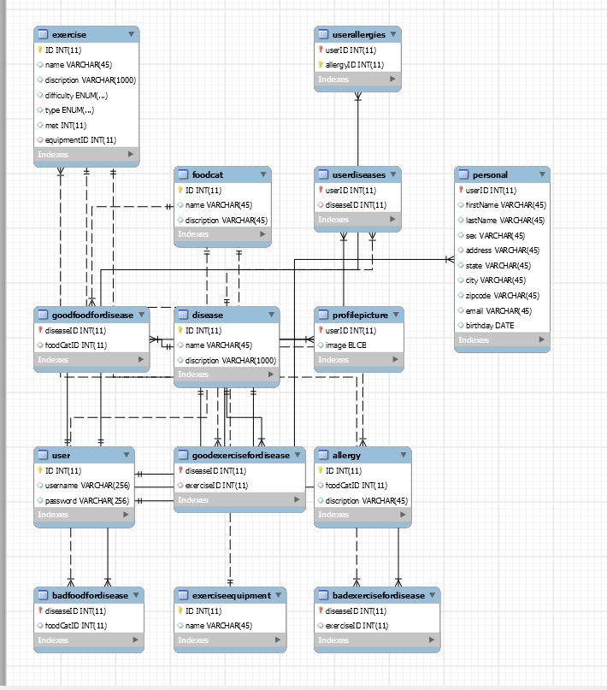

### 3.2.1 table1

...

### 

|  |  |
| --- | --- |
| **Tab Manager** | |
| The Tab Manager is used to navigate through the application. | |
| **Attributes** | **Description** |
| instance | singleton |
| getInstance() | returns the current instance |
| OpenHome() | Opens home tab |
| OpenProfilePersonal() | Opens profile personal tab |
| OpenProfileMedical() | Opens profile medical tab |
| OpenProfileExercise() | Opens profile exercise tab |
| OpenProfileExport() | Opens profile export tab |
| OpenRoutineHome() | Opens routine home tab |
| OpenRoutineCreator() | Opens routine creator tab |
| OpenRoutineManger() | Opens routine manager tab |
| OpenExercises() | Opens exercies tab |
|  |  |

### 

### 

Class: LoginContoller.java

|  |  |
| --- | --- |
| **Login Controller** | |
| Manages the GUI components for the login tab | |
| **Attributes** | **Description** |
| TextField usernameTF | username input |
| TextField passwordTF | password input |
| Label errorL | displays errors to user |
| String password | saves current password entered |
| **Methods** | **Description** |
| initialize() | initilize fields |
| OpenCreateAccount() | opens create account tab |
| OpenHome() | opens home tab |
| Login() | Logs into account and opens home tab |
| RetreiveProfile() | gets profile from database |

Class: HomeContoller.java

|  |  |
| --- | --- |
| **Home Controller** | |
| Manages the GUI components for the home tab | |
| **Methods** | **Description** |
| OpenExercise() | opens exercise tab |
| OpenRoutine() | opens routine tab |
| Logout() | signs out and opens login tab |

### 

Class: PersonalController.java

|  |  |
| --- | --- |
| **Personal Controller** | |
| Manages the GUI components for the profile personal tab | |
| **Attributes** | **Description** |
| ArrayList<String> states | list of the states in the U.S. |
| TextField fNameTF | first name input |
| TextField lNameTF | last name input |
| TextField zipTF | zipcode input |
| TextField addressTF | address input |
| TexField cityTF | city input |
| TextField emailTF | email input |
| TextField birthdayMonthTF | birthday month input |
| TextField birthdayDayTF | birthday day input |
| TextField birthdayYearTF | birthday year input |
| ComboBox sexCB | sex input |
| ComboBox stateCB | state input |
| ImageView profielIV | displays profile image |
| ImageFile imageFile | stores uploaded image file |
| **Methods** | **Description** |
| initialize() | initilize fields and calls DisplayPersonal() |
| OpenMedical() | opens profile medical tab |
| OpenHome() | opens home tab |
| OpenExercise() | opens profile exercise tab |
| OpenExport() | opens export tab |
| SavePersonal() | saves personal information from GUI fields to user’s profile |
| DisplayPersonal() | displays user personal information to the GUI |
| UploadProfilePic() | allows user to upload profile pic |

### 

Class:MedicalController.java

|  |  |
| --- | --- |
| **MedicalController** | |
| Manages the GUI components for the medicalpersonal tab | |
| **Attributes** | **Description** |
| TextField weighTF | input weight |
| TextField heightTF | height input |
| CheckListView allergyCLV | allergy check box list |
| CheckListView diseaseCLV | disease check box list |
| TextArea diseaseTA | displays information about disease |
| TextArea allergyTA | displays information about allergy |
| ArrayList<Disease> diseaseList | disease list to store user diseases |
| ArrayList<Allergy> allergyList | disease list to store user allergies |
| **Methods** | **Description** |
| initialize() | initilize fields and calls DisplayMedical() |
| OpenMedical() | opens profile medical tab |
| DisplayMedicalProfile() | displays user medical information to the GUI |
| OpenPersonal() | opens profile personal tab |
| OpenExercise() | opens profile exercise tab |
| OpenHome() | opens home tab |
| SaveMedical() | saves medical information from GUI fields to user’s profile |

### 

### 3.2.2 table2

...

# 4. User Interfaces By Use Case

There are no models at this moment. However, an initial data model can be found I Appendix.

## 4.1

**Use Case 01:**

There are no sequence diagrams at this stage of the development process.

## 4.2

**Use Case 02:**

...

# A. Appendices

## A.1 Appendix 1

Required form for approval of changes to this document.

# Document Approval

The following Software Requirements Specification has been accepted and approved by the following:

|  |  |  |  |
| --- | --- | --- | --- |
| **Signature** | **Printed Name** | **Title** | **Date** |
|  | Izquierdo Stephen | Lead Software Eng. |  |
|  | Dr. M. K. Quweider | Instructor, CSCI-3340 |  |
|  |  |  |  |

## A.2 Appendix 2

Required form needed if there are any changes after the document is completed.

# Revision History

|  |  |  |  |  |
| --- | --- | --- | --- | --- |
| **Date** | **Description** | | **Author** | **Comments** |
| 11/2/2017 | Version 1.0 | Yessenia Rodriguez, Stephen Izquierdo | | First Draft |
|  |  |  | |  |
|  |  |  | |  |
|  |  |  | |  |